Data Center Shared Services: Service Level Description

Introduction
Data Center Shared Services is a campus initiative to consolidate campus server rooms and data centers into high-quality shared data center facilities. Through use of shared data centers, the campus can provide higher-quality facilities while reducing overall costs.
This Service Level Description (SLD) describes the Data Center Shared Services (DCSS) offerings. DCSS provides a set of standard services for data center co-location. The standard services are provided by the campus and available at no charge to eligible units of the University of Illinois Urbana Campus. Additional (non-standard) services may be offered for a fee. Non-eligible units (not eligible for campus funded services) are permitted to purchase services.
The Data Center Shared Services Operations Committee (DCSS ops) is the primary point of contact for all DCSS tenants. DCSS has operational staff managing each of the shared data center locations.

General Overview
The DCSS SLD documents the following:
- Standard Services
- Additional Services
- Eligible Campus Units
- Shared Data Center Locations
- Environment
- Security and Access Provisions
- Data Center Shared Services Service Desk
- Data Network Provisions
- Disaster Recovery
- Notifications and Tennant Communications
- Operational Support
- Definitions
- Contact Us!

Data Center Locations
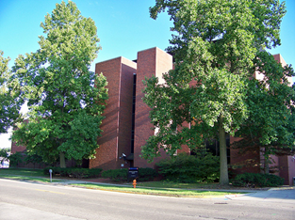 | Advanced Computation Building (ACB)  The Advanced Computation Building houses the campus research cluster and is available at no cost for additional research computing needs. This is the primary campus DCSS data center. It is located at 1011 W. Springfield Ave., Urbana.
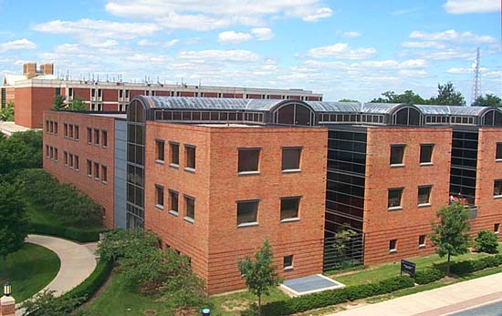 | Digital Computer Laboratory (DCL)  Digital Computer Laboratory provides DCSS services to campus. This location serves to provide additional redundancy and generator service. At this locations there is also UPS support at no cost. DCL is located at 1304 W. Springfield Ave., Urbana.
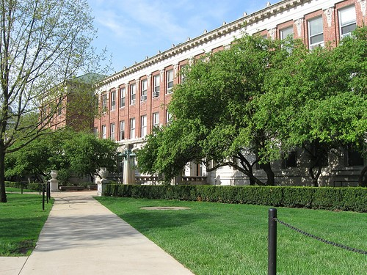 | Henry Administration Building (HAB)  Henry Administration Building also provides DCSS services to the Urbana campus. This location serves to provide additional redundancy. HAB is located at 506 S. Wright Street, Urbana.

Standard Services
The following services are provided as standard DCSS services.
Data Center Coordinator Support and Annual Review Planning Process | Tenants have the support of a data center IT Technical Associate to ensure client’s needs are met.
UPS and Generator Services | All spaces have availability of centralized UPS. DCL location is the only site with generator resources. Please reference our power policy online at (policy to be written).
Data Center Campus Network Service | Standard 1 gigabit Ethernet to campus backbone is available at all DCSS locations. All connections will be available in Lens/Iris and may be managed by the tenant as well as DCSS staff.
Video Surveillance Management | DCSS locations are monitored with video surveillance.
Standard Racks Supported | Standard racks are 19 or 23 inch mounts with side panels and combination or key locks available upon request.
Power Management | DCSS provides dual 20 or 30 amp PDUs in each cabinet, fitting C15 or C19 power cables.
crash cart availability | A crash cart is available for use at each location.
Access and Physical Security Management | All locations are secured 24*7. Access is granted by contacting DCSS IT Technical Associate.
Hardware Installation Support | Hardware installation support is part of the DCSS service and is scheduled as part of the planning process. All locations access to a freight elevator, staging area, and loading dock. Tenants may elect to have DCSS staff install the equipment for them or install hardware themselves. If installation is done by tenant, DCSS staff will be present to assist with cable management, guideline adherence, and general assistance. Tenants will need to make an appointment with the facility staff when items are to be delivered to each location. General hours of availability are Monday through Friday from 8 to 5.
Staging Area | A staging area is available for unpacking hardware for installation to reduce the amount of debris in the data center. In ACB this space is in room 202, in DCL this space is the room outside the data center, and in HAB the helpdesk can show you the space available.
Fire Detection and Suppression Systems | HAB, and DCL have the Fike fire suppression system. ACB has a water-dry pipe system. ACB and DCL also have VESDA detection.
Temperature Controlled Environment | All data centers are temperature controlled. Temperature varies between 68 and 72 degrees depending on location. All locations manage humidity levels via the HVAC systems installed in the spaces.
Change Control and Incident Management | The ITIL incident management process is used to notify tenants of events. This is done through change control along with event notices. All tenants are part of the DCSS Event Notice distribution list.
Support and Maintenance | Data Center Infrastructure components and systems are covered under support and maintenance contracts and tested at least annually depending on component.

Additional Services
Additional services (non-standard) may be available at an additional fee and offered by other units within the University. DCSS doesn't restrict our clients from using additional services provided by other campus entities at the client’s expense.

Environment
Through the DCSS funding model, infrastructure will be under support and maintenance provided by the Data Center Shared Services Operations Committee Staff (DCSS ops). This will occur at no additional cost and includes power, cooling, access and video surveillance systems, and UPS.
Change controls and planned outages will occur during the standard change control window and clients will be notified in a timely manner.
In the case of a planned outage for data center infrastructure systems (power, cooling, and networking), each tenant will be contacted in advance.

Security and Access Provisions
Physical card access to the facility is provided by contacting the DCSS staff upon initial entry to the data center. Depending on location, requests could take up to three business days to add additional clients.

DCSS Service Desk
The Data Center Shared Service Desk is available 24 hours a day, 7 days a week to support tenant’s needs. Please file a ticket by emailing help@datacenter.illinois.edu or call the service desk at 217-333-3102 or 312-996-4806. The DCSS service desk will be the primary point of contact and is available to quickly escalate problem tickets or incidents.
All tickets will be routed to the appropriate groups immediately. In the event of an emergency, DCSS staff will respond in a timely manner.

Change Control Process
The DCSS Change Control Process will be defined by site. As servers are racked and additional hardware is installed and/or decommissioned, change controls must be filed. The tenant will be responsible for filing this change while DCSS staff provides approval.

Data Network Provisioning
All DCSS footprints provide the campus network. As needed, requests are made to CITES or AITS depending on the location of the space. DCSS staff will guide incoming departments on the appropriate process during the entrance meeting.

Inventory
Tenants are responsible for maintaining the inventory of their equipment, according to University policies.

Business Continuity Planning
It is the responsibility of each department in DCSS space to report the loss of hardware due to fire, tornado or other disaster. The DCSS effort will assist with relocating to another shared space. This will occur by priority depending on the critical business needs of the overall campus. For additional departmental details, refer to the University of Illinois Public Safety Business Continuity Department.

Operational Support
Facility conditions are monitored 24 hours a day, 7 days a week. DCSS staff is available to provide physical access in case of emergency. As described in the services section, all data center services are provided, while hardware support and maintenance are not. Tenants are responsible for establishing operating agreements with other shared service providers that they use.

Contact
For more information, please contact the Data Center Shared Services Operations Team at help@datacenter.illinois.edu.
Want to move forward now? Please fill out this entrance form and email the pdf copy to help@datacenter.illinois.edu. An introduction meeting will be scheduled to plan the move and discuss all special requirements. Depending on the request and networking needs, physical space may be allocated in as little as 15 working days of the initial request.

